specification
Model： WB860H-32

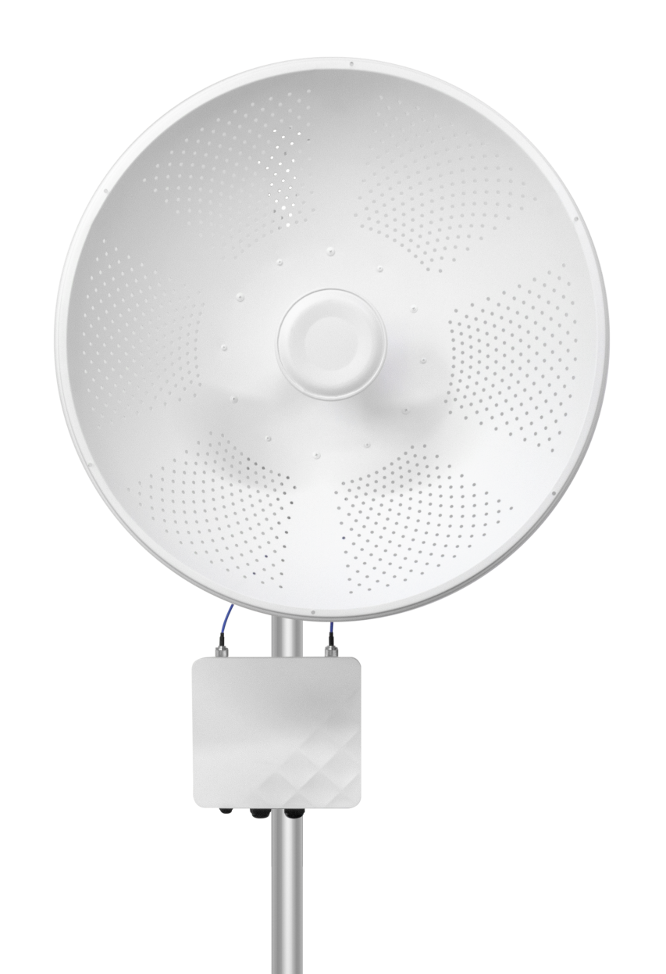

Brand and Manufacturer Information
Brand: Neutral
LOGO： neutral

Model and Version
Model: MWS-WB860H-32
Version: V1.0

Product Overview and Features
Product Overview
The MWS-WB860H-32 is a high-performance, high-speed industrial-grade long-range wireless bridge featuring extensive transmission range, strong signal penetration capability, and excellent interference resistance.
product features
- The use of specialized TVS lightning protection devices enhances the product's performance under harsh environmental conditions.
- Equipped with an external 32 dBi bipolar directional antenna, with a maximum coverage range of up to 35 kilometers.

- Supports both 24–48 V PoE power supply and 12 V DC power supply.
- TDMA Intelligent Dynamic Polling Protocol
- Supports ATPC power control
- Supports IPv6

technical parameter
Specification Parameters
product model | WB860H-32
CPU | QCA9563+QCA9882+QCA8334
Flash | SPI NOR 16MB
DDR | DDR2-128MB
5G Operating Frequency Bands | 5.150GHz～5.850GHz
5G Wi-Fi Transmission Protocol | 802.11 a / n /ac
top speed | 867Mbps
antenna | Two N-F connectors, external parabolic antenna, gain: 32 dBi
5 GHz wireless power | 802.11a | 54M | 23±2dBm | 6M | 26±2dBm
5 GHz wireless power | 802.11n HT20 | MCS7 | 22±2dBm | MCS0 | 26±2dBm
5 GHz wireless power | 802.11n HT40 | MCS7 | 22±2dBm | MCS0 | 26±2dBm
5 GHz wireless power | 802.11ac VHT20 | MCS9 | 21±2dBm | MCS0 | 26±2dBm
5 GHz wireless power | 802.11ac VHT40 | MCS9 | 21±2dBm | MCS0 | 26±2dBm
5 GHz wireless power | 802.11ac VHT80 | MCS9 | 21±2dBm | MCS0 | 26±2dBm
5 GHz reception sensitivity | 802.11a | 54M | -75dBm | 6M | -92dBm
5 GHz reception sensitivity | 802.11n HT20 | MCS7 | -72dBm | MCS0 | -90dBm
5 GHz reception sensitivity | 802.11n HT40 | MCS7 | -69dBm | MCS0 | -88dBm
5 GHz reception sensitivity | 802.11ac VHT20 | MCS9 | -65dBm | MCS0 | -88dBm
5 GHz reception sensitivity | 802.11ac VHT40 | MCS9 | -62dBm | MCS0 | -86dBm
5 GHz reception sensitivity | 802.11ac VHT80 | MCS9 | -59dBm | MCS0 | -84dBm
5G EVM | 802.11a_54M: ≤-25 dB；802.11n_MCS7: ≤-28 dB；802.11AC_MCS9:≤-32dB
frequency deviation （ppm） | ±20ppm
Interface (WAN) | One 10/100/1000 Mbit/s adaptive WAN port, supporting 24–48 V POE power supply
Interface (LAN) | 1 adaptive LAN port with speeds of 10 Mbps, 100 Mbps, or 1000 Mbps
supply electricity | Supports PoE 24V Passive and DC 12–24V; customizable with a 48V PoE version compliant with IEEE 802.3af standards
maximum power dissipation | < 15W
RST key | Reset Key (hold for 6–10 seconds to restore factory settings)
State Indicator Light | SYS light, WAN port light, LAN port light, signal lights ×5
product size | 243mm*218mm*67mm
weight | 1.756 kg (main unit), 2.984 kg (gross weight)
work environment | Normal operating temperature: -40°C to 70°C; Maximum operating temperature: -40°C to 70°C  Storage temperature: -40°C to 70°C; Humidity: 5% to 95% (no condensation)
levels of protection | IP67
ESD | Air discharge: ±15 K; Contact discharge: ±8 K
surge | Common-mode 4K, differential-mode 2K

software function
Wireless Mode | Access Point (Automatic WDS), Access Point (TDMA3), Site (WDS/TDMA3), Site (ARPNAT)
Wireless Technology | Smart dynamic polling, automatic channel selection, automatic modulation method selection, and Automatic Transmission Power Control (ATPC)
Wireless Security | WPA/WPA2 Personal Encryption, WPA/WPA2 Enterprise Encryption, WACL, User Isolation
wireless QoS | TDMA implements 4-channel priority
Network Mode | IPv4 to IPv6 Bridging
network technique | Supports VLAN and VLAN forwarding
WAN protocol | Static IP, DHCP Client
serve | DHCP service, SNMP service, NTP client, route tracking, ping watchdog
manage | HTTP(S) GUI, SSH, SNMP read, WNMS, Telnet
tool | Site Survey, Connection Test, Antenna Calibration

Interface Diagram
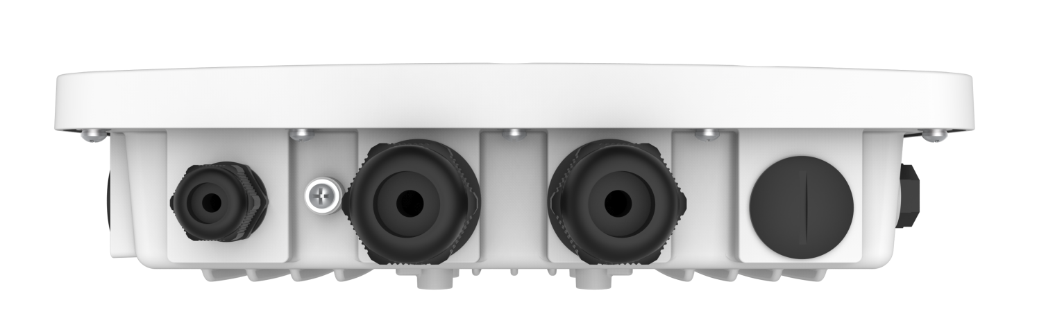

Product Size Diagram
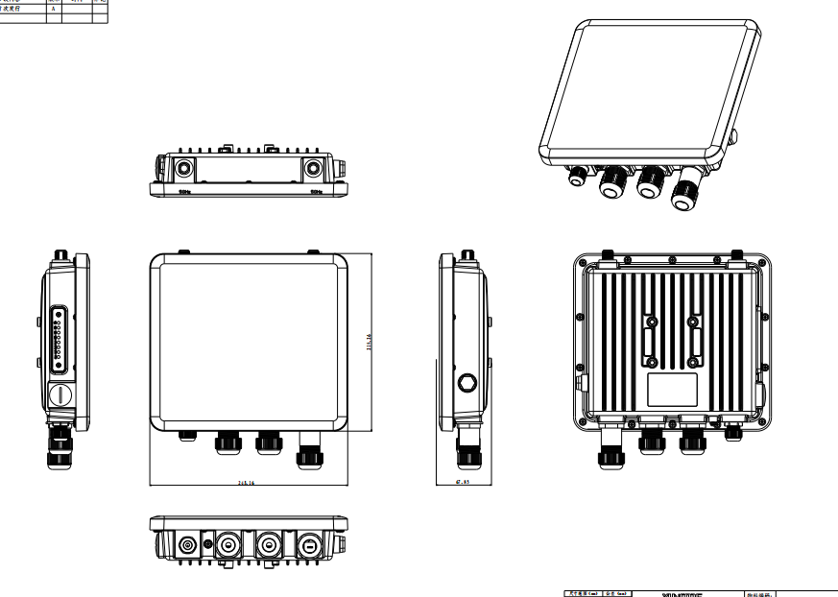

Antenna Specifications

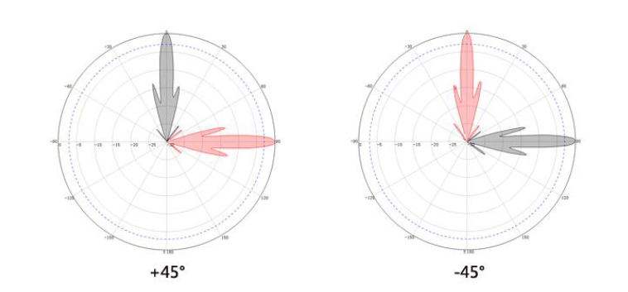

External Antenna
Working Frequency Band | 5180 ~5850 MHz
gain | 32 dBi
Polarization Method | ±45° bipolarization
Cross-polarization isolation degree | 30 dBi
Maximum Standing Wave Ratio | <1.8
Horizontal flap angle | 3.4 °
Vertical flap angle | 3.4 °
rough weight | 14kg/2pcs

Attachment List
Host ×1; Ethernet cable ×1; PoE module ×1; Power cord ×1; Ethernet port interfaces ×2; L-shaped bracket ×1; Installation kit ×3; User manual ×1; Certificate of conformity and warranty card ×1

